Experiment 6: Weather Data Analysis (Temperature Analysis)

Objective : Analyze temperature data to find the hottest and coldest days using MapReduce. Dataset (Create This)

Procedure
Step 1: Create Dataset
Step 2: Expand Dataset
Step 3: Reducer (Hottest Day)
Step 4: Run Hadoop Job (Hottest Day)
Step 5: Reducer (Coldest Day)

ScreenShot
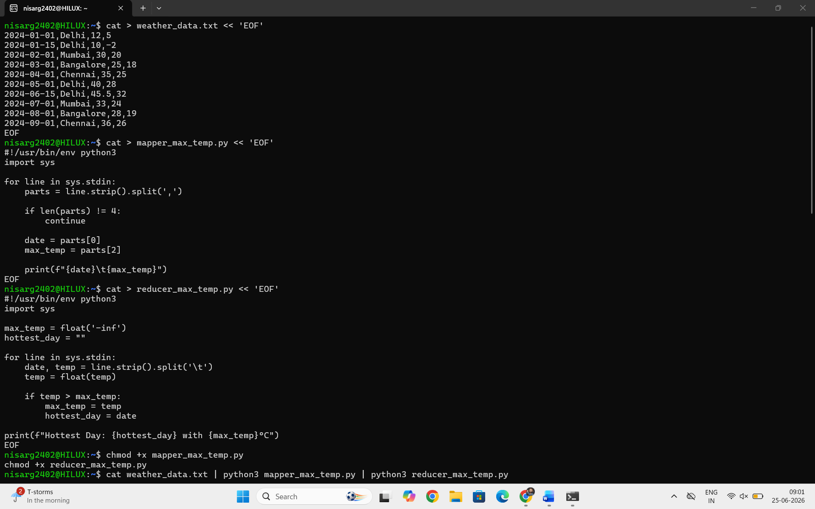
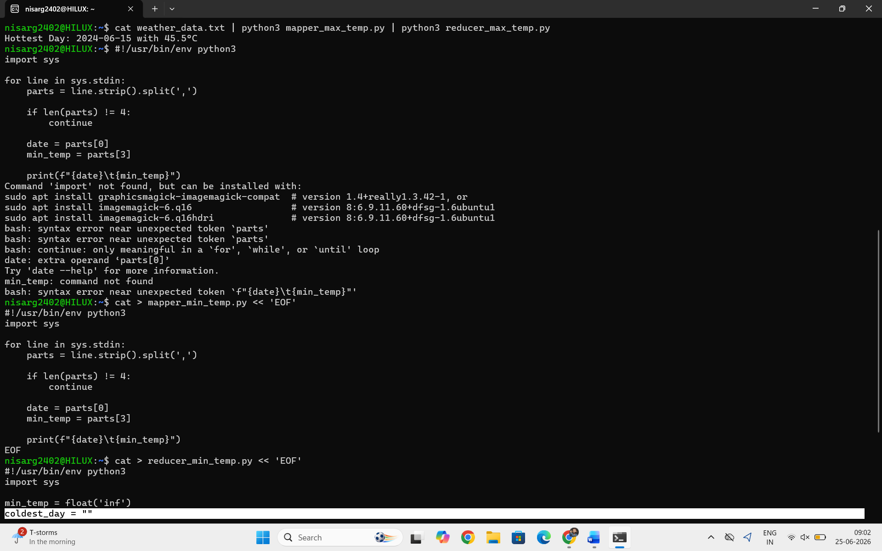
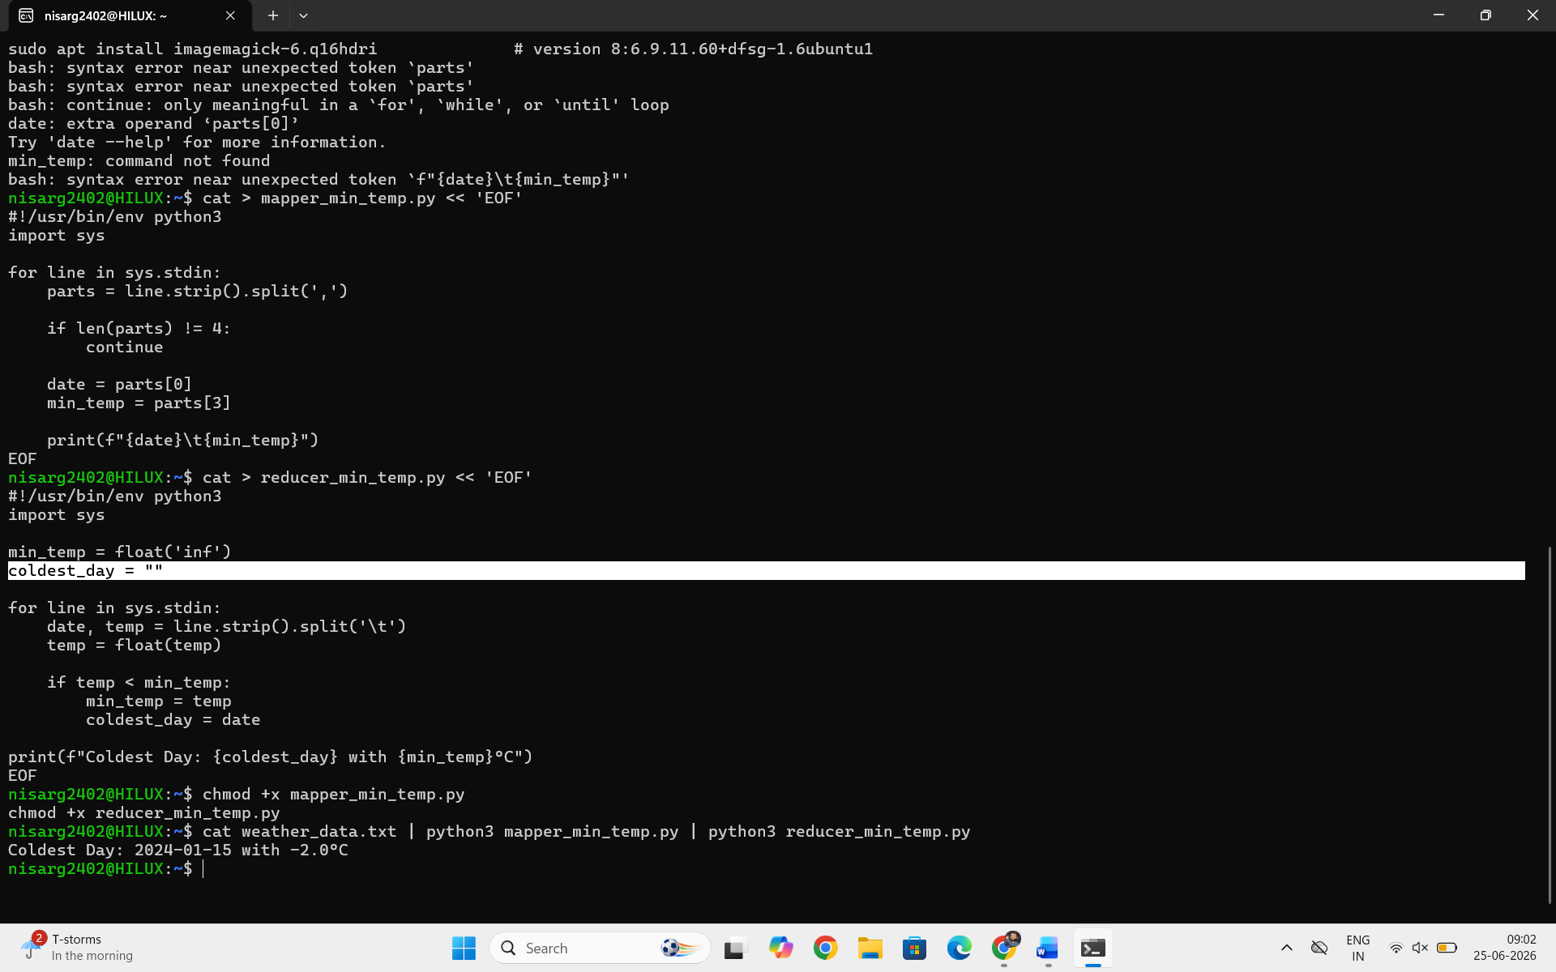

Conclusion
In this experiment, we successfully implemented a MapReduce-based weather data analysis system using Hadoop Streaming.
Key Outcomes:
- Extracted maximum temperature per day using Mapper-Reducer model.
- Identified the hottest day in the dataset.
- Identified the coldest day using a separate reducer.
- Learned how distributed processing works using Hadoop.
Learning:
- Mapper processes raw input and emits key-value pairs.
- Reducer aggregates and computes final results.
- Hadoop Streaming allows Python integration with Hadoop.

